Nama : Wisnu Kusumo Jati

NIM : 18090081

Kelas : 5B

**PRAKTIKUM 1**

1. Source Code

Perkenalan.php -> application/controller

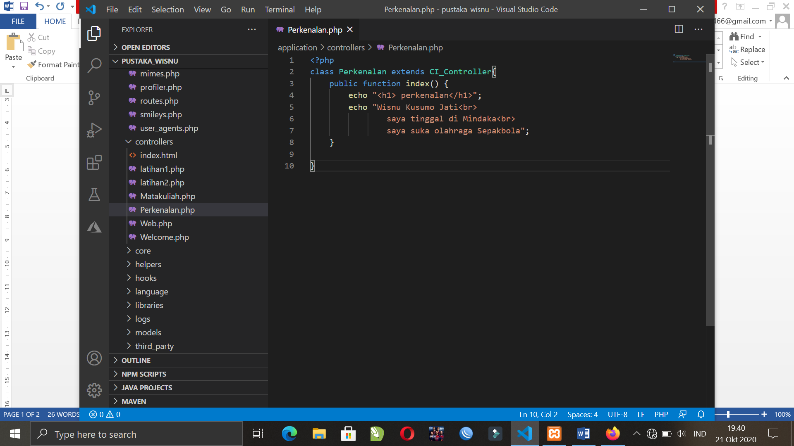

1. URL

<http://localhost/pustaka_wisnu/index.php/Perkenalan>

1. Capture Hasil

